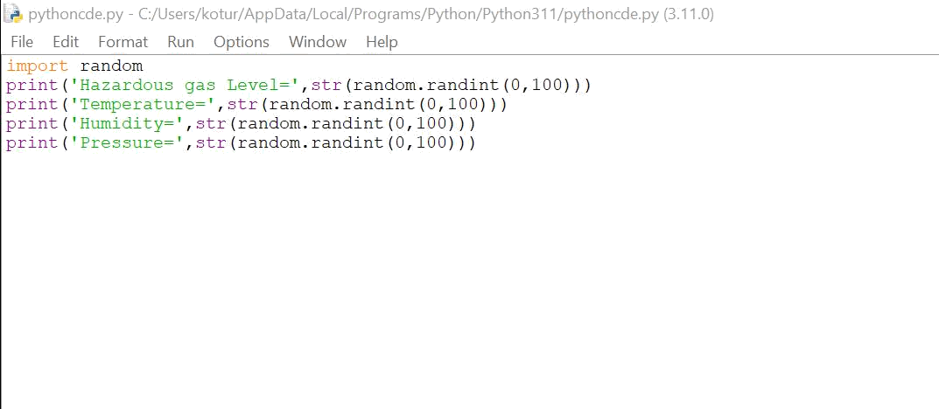

**PYTHON CODE**

**Date**

2022

NOVEMBER

9

**Team ID**

PNT2022TMID08507

**Project Name**

GAS LEAKAGE MONITORING AND ALERTING SYSTEM FOR INDUSTRIES

**Code:**

**import random**

**print('Hazardous gas**

**Level=',str(random.randint(0,100)))**

**print('Temperature=',str(random.randint(0,100)))**

**print('Humidity=',str(random.randint(0,100)))**

**print('Pressure=',str(random.randint(0,100)))**

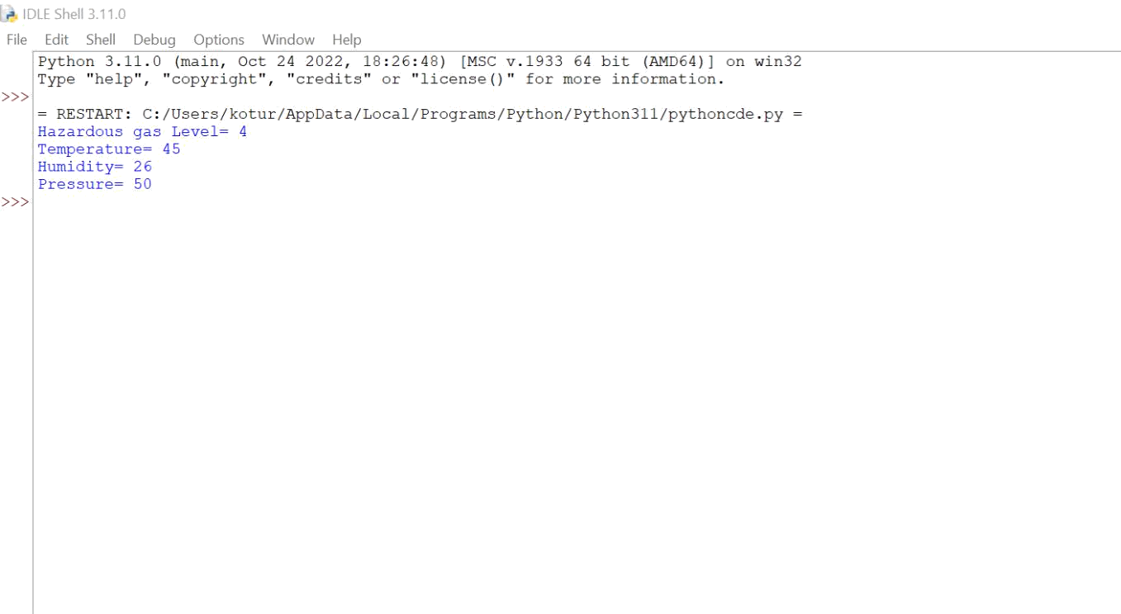

Output:

Python code was developed Successfully

